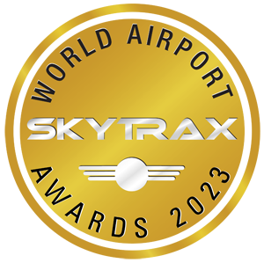
The World's Top 20 Airlines – 2023
- Singapore Airlines
- Qatar Airways
- ANA All Nippon Airways
- Emirates
- Japan Airlines
- Turkish Airlines
- Air France
- Cathay Pacific
- EVA Air
- Korean Air
- Hainan Airlines
- Swiss Int’l Air Lines
- Etihad Airways
- Iberia
- Fiji Airways
- Vistara
- Qantas Airways
- British Airways
- Air New Zealand
- Delta Air Lines

Singapore Airlines has been voted the World’s Best Airline at the 2023 World Airline Awards, the fifth time that the airline has scooped the Airline of the Year title in the 23 year history of the awards.

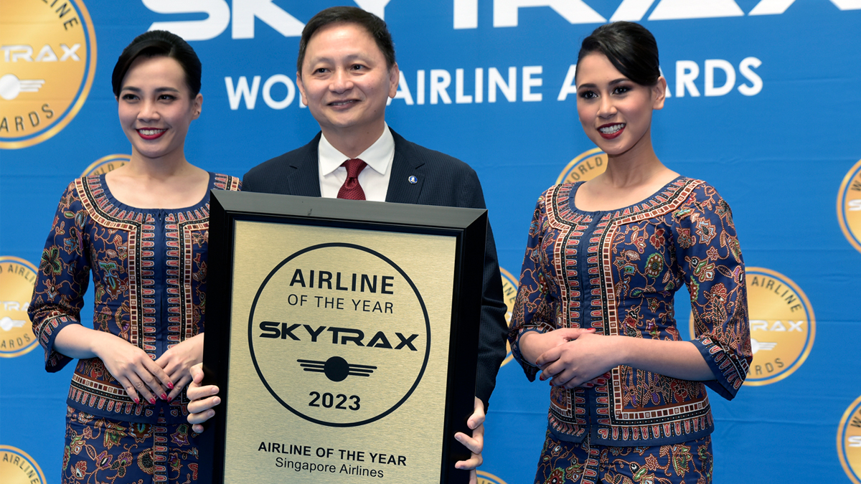

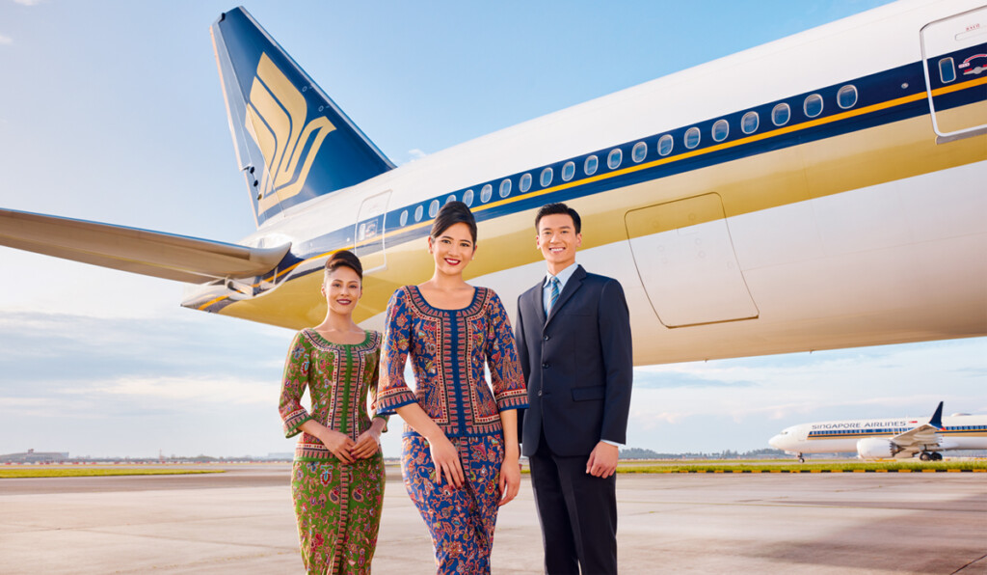

Singapore Airlines named World’s Best Airline at 2023 World Airline Awards


The 2023 World Airline Awards to be held at the 2023 Paris Air Show
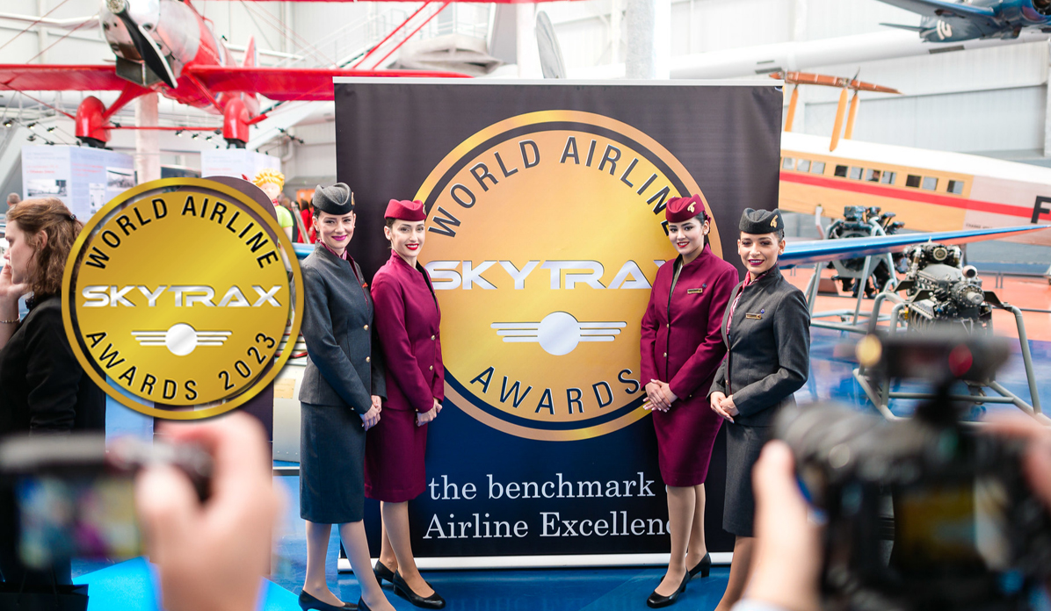

The World Airline Awards

The World Airline Awards are the primary benchmarking tool for Passenger Satisfaction levels of airlines throughout the world, delivering a unique survey format based on analysis of business and leisure travellers, across all cabin travel types (First Class, Business Class, Premium Economy Class and Economy class passengers).
Air travellers were surveyed by telephone, questionnaires and online about their experiences with airlines on the ground and in the air during a 10-month period. The survey measured passenger satisfaction across more than 38 key performance indicators of airline front-line product and service, including check-in, boarding, onboard seat comfort, cabin cleanliness, food, beverages, in-flight entertainment and staff service. The Survey covered over 200 airlines, from the largest international airlines to smaller domestic carriers.

(Source: World Airlines Awards)

