SCSC awarded 2nd Best Warehouse GHA 2022 by Turkish Cargo

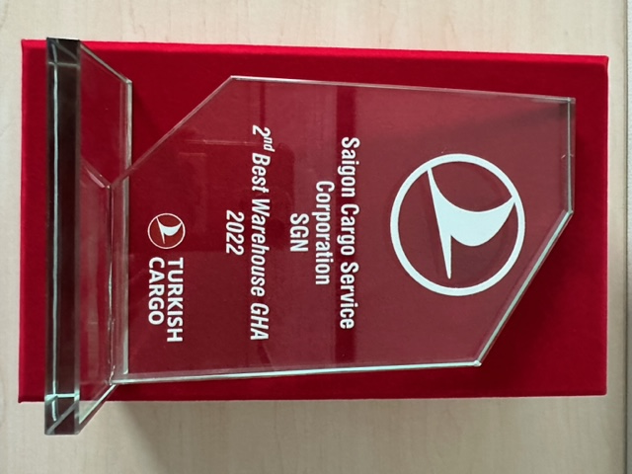

After the entirely review and evaluation of the air cargo handling performance well done by Turkish Cargo from all of their stations in the world in 2022 , Saigon Cargo Service Corporation SGN (SCSC) has been delighted to be chosen as and awarded the 2nd Best Warehouse GHA 2022. The Award Ceremony was held during IATA World Cargo Symposium 2023.

This recognition is a testament to SCSC's consistent commitment to excellence in providing exceptional cargo terminal services to all customers.

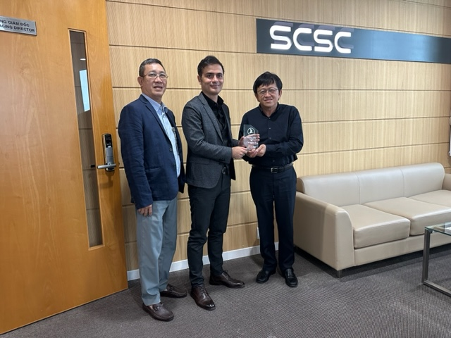

SCSC is proud of being a partner with and of serving Turkish Cargo as well, and we look forward to continuing to provide Turkish Cargo with the best air cargo handling services at SGN station.

We also appreciated with sincere thanks for Turkish Cargo’s evaluation and recognition.

*(Source: Turkish Cargo)*